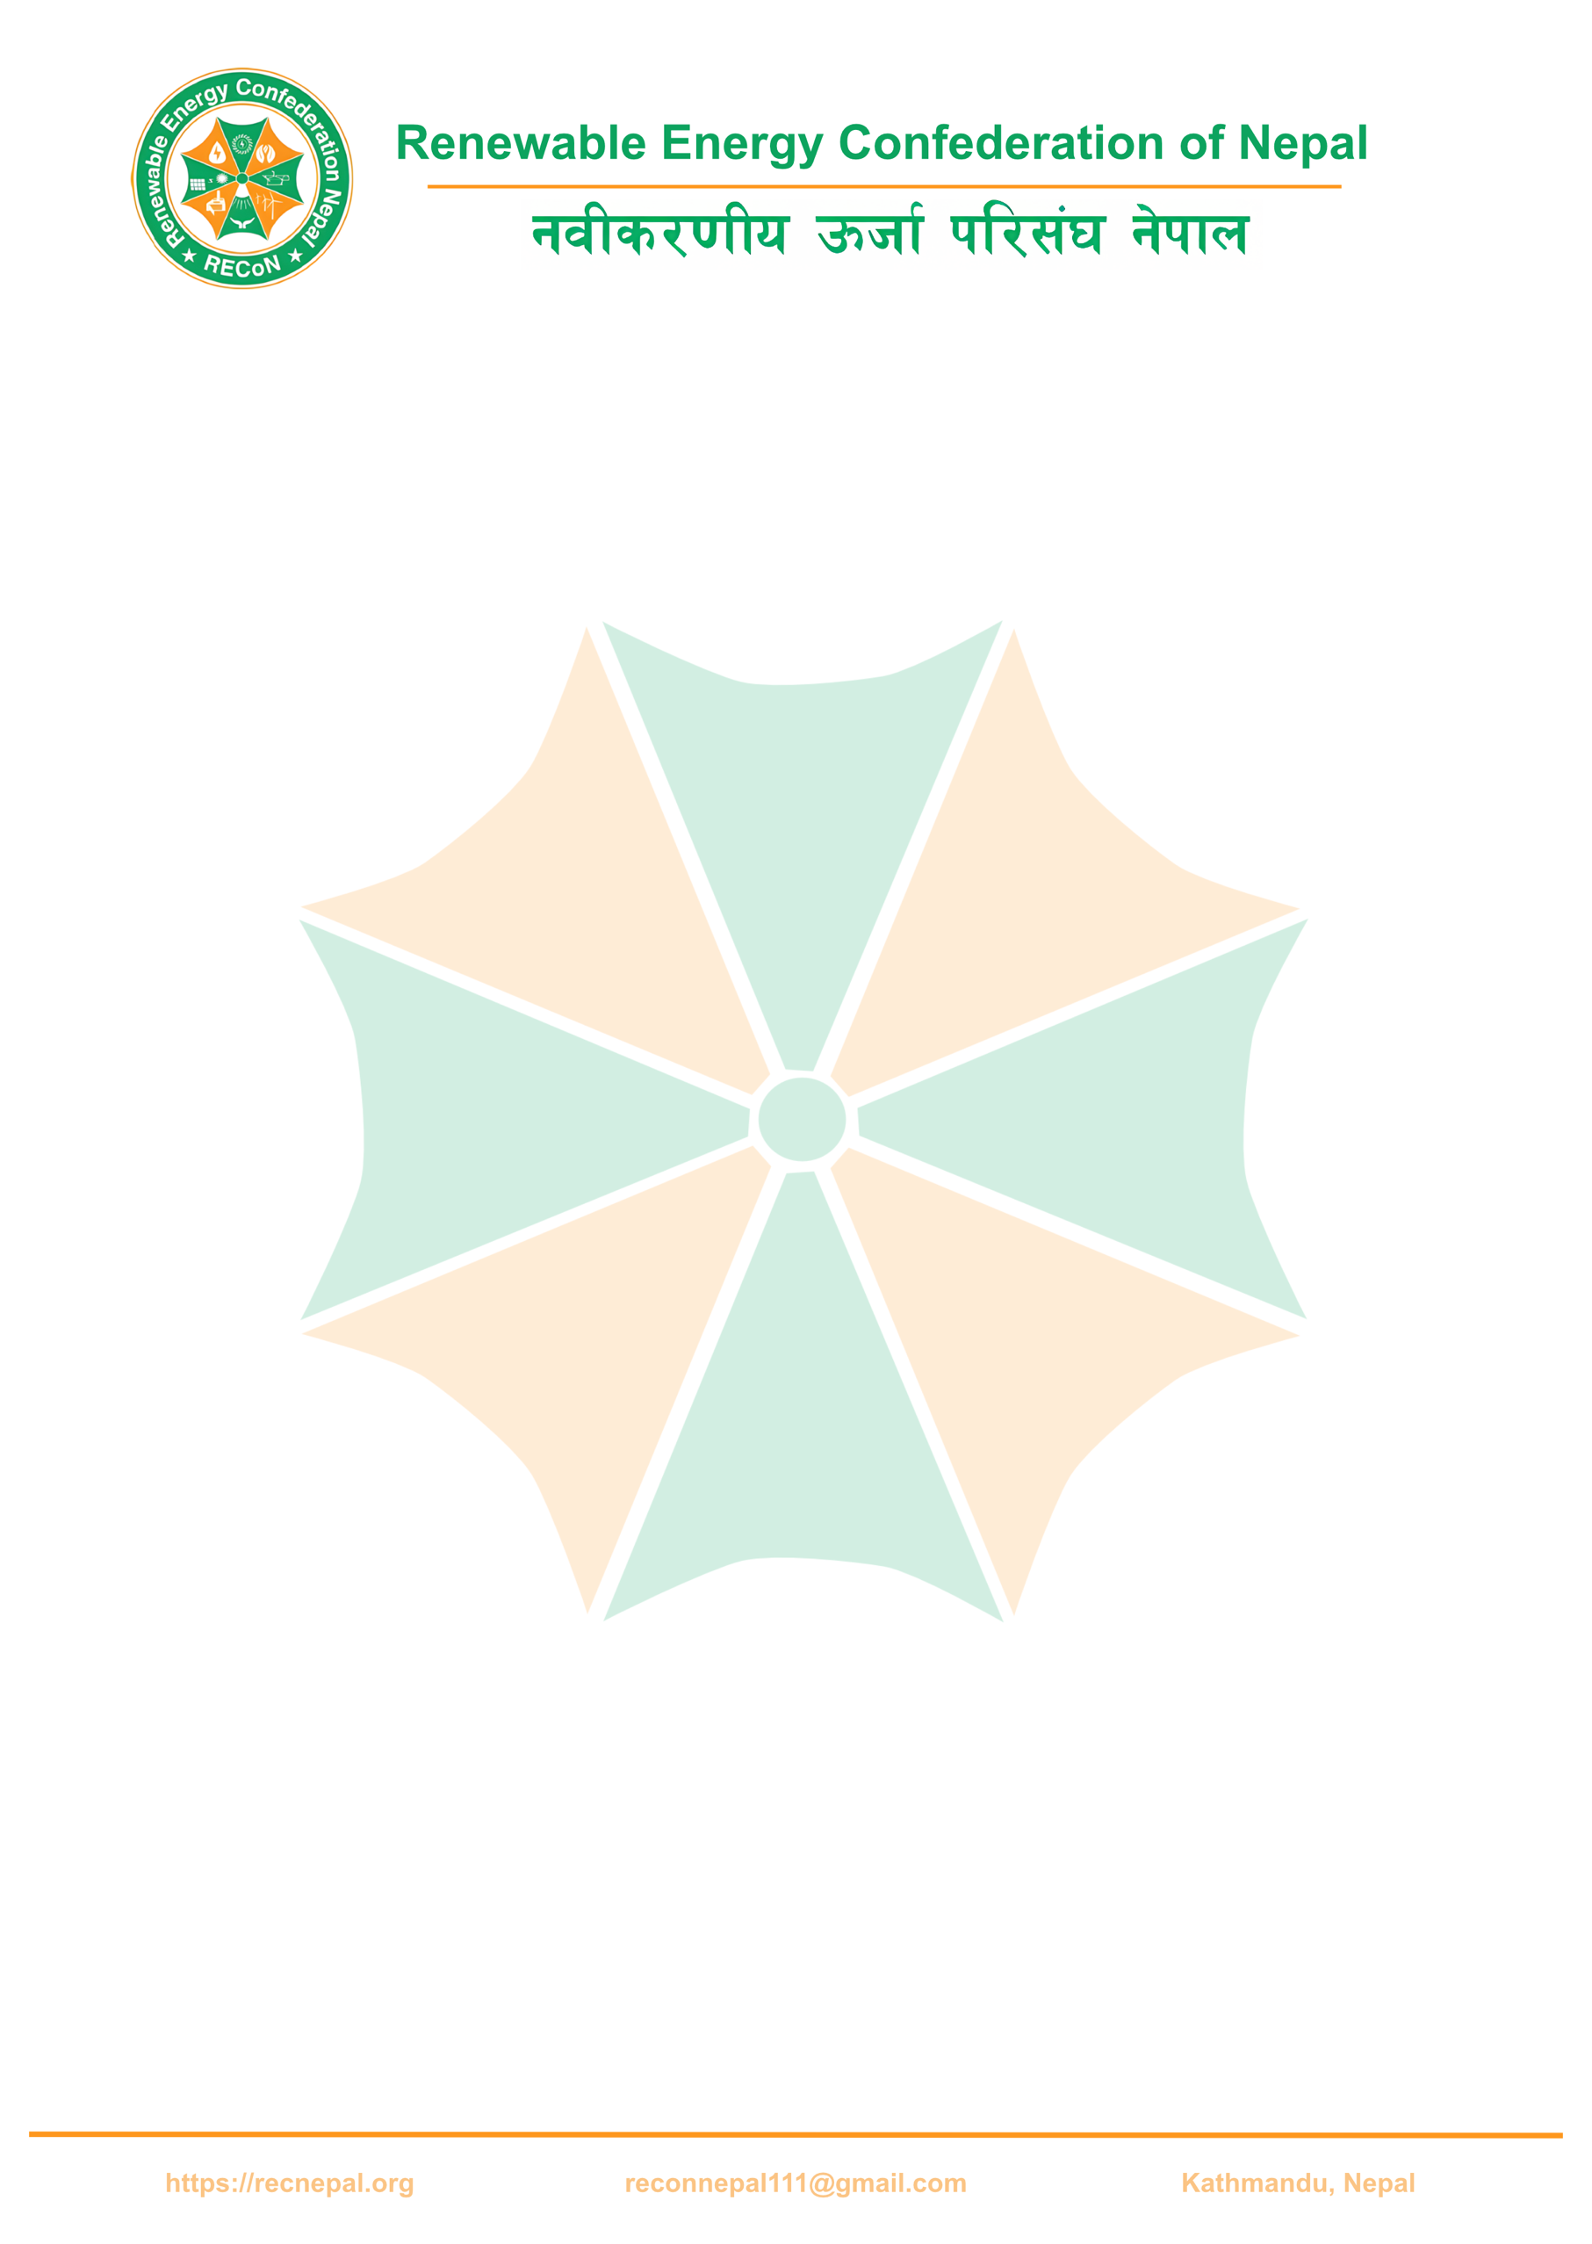
The Renewable Energy Confederation of Nepal (RECON) invites quotations from qualified and experienced solar system suppliers and installers for the design, supply, installation, testing, and commissioning of solar photovoltaic (PV) systems under the DFAT-supported project titled “Sustainable Healthcare Service through Renewable Energy at Roshi Rural Municipality, Kavrepalanchowk District.”
1. Project Overview
The project aims to improve the reliability and continuity of electricity supply at selected public health facilities in Roshi Rural Municipality through the installation of solar PV systems with battery backup. These systems are intended to support essential healthcare services during frequent grid outages and emergency situations, ensuring uninterrupted operation of critical medical equipment such as vaccine refrigerators, delivery lighting, suction machines, oxygen concentrators, and basic ICT equipment.
2. Scope of Work
The selected bidder shall be responsible for the following activities on a per-site basis:
- Detailed system design for a 5 kWp solar PV system (only the essential loads).
- Supply of all required equipment and materials
- Transportation of equipment and materials to the project site
- Installation, testing, and commissioning of the complete system
- Integration with existing electrical infrastructure at the health facility
- Provision of operation and maintenance manuals
- Basic orientation and handover briefing to designated health facility staff
3. Technical Requirements (Indicative)
Nominal solar PV capacity: 5 kWp per site
Solar PV modules:
Monocrystalline solar PV modules with a rated capacity of 410 Wp per panel
Modules shall be IEC-certified and suitable for long-term outdoor operation
System type:
Grid-connected solar PV system with battery backup (hybrid configuration), capable of supplying power during grid outages

Inverter:
5 kVA inverter, capable of handling upto 60 V battery system
Suitable for grid-tied operation with battery-backed functionality
Battery storage:
Lead-acid GEL batteries of 150 Ah capacity
Battery bank shall be sized to adequately support the essential electrical loads of the facility, provide sufficient backup during grid outages, and ensure uninterrupted operation of critical medical equipment
Mounting structures:
Mounting structures suitable for RCC or metal-sheet roofing, including all fasteners and accessories
Electrical protection and accessories:
- DC and AC protection devices
- Surge protection devices (SPD)
- DC and AC isolators
- Proper earthing and grounding system
- Junction boxes, combiner boxes, conduits, and all necessary accessories
The final battery capacity, string configuration, and detailed system layout shall be proposed by the bidder based on site load requirements and shall be subject to approval during the detailed design stage.
4. Project Sites
The project includes installations at the following public health facilities in Roshi Rural Municipality:
- Sipali Chilaune Birthing Center
- Mangaltar Birthing Center
- Katunje Health Post
Quotations must be submitted on a per-site basis, clearly indicating unit rates and total costs.

5. Quotation Submission Requirements
Interested bidders are requested to submit the following documents:
- Technical proposal including system configuration and specifications
- Detailed Bill of Quantities (BOQ) with unit rates and total cost
- Proposed installation timeline per site
- Warranty details for solar modules, inverter, batteries, and workmanship
- Company profile and experience in similar solar PV projects
- Valid business registration certificate, PAN/VAT registration, and latest tax clearance
- Details of after-sales service, maintenance support, and response time
6. Evaluation Criteria
Quotations will be evaluated based on:
- Compliance with technical requirements and specifications
- Cost effectiveness and value for money
- Relevant experience and past performance in similar projects
- Warranty terms and after-sales service provisions
- Compliance with DFAT and SWC procurement requirements
RECON reserves the right to accept or reject any or all quotations without assigning any reason.
7. Submission Deadline
Quotations must be submitted on or before 30th December 2025.
Submissions shall be made by email to:
reconnepal11@gmail.com
We appreciate your interest in supporting renewable energy solutions for rural healthcare services.
Sincerely,
Renewable Energy Confederation of Nepal (RECON)
Kathmandu, Nepal

